# freETarget

Application Note: Tabata & Rapid Fire Training

**SUMMARY**

Tabata training gives you a set period of time to get on target and take the shot. In rifle it is used to train out of overholding, on pistol it simulates a rapid fire event.

**REQUIRED**

* freETarget V2.1 or higher
* Firmware V3.9.4 or higher

**INTRODUCTION**

The freETarget firmware supports Tabata training and Rapid Fire events. The two are fundamentally the same, but the Tabata training is one shot in a timed interval, while Rapid fire accumulates a number of shots in a defined interval.

Both Tabata and Rapid are controlled by JSON commands that are entered into the target using the Arduino (generic command) dialog box.

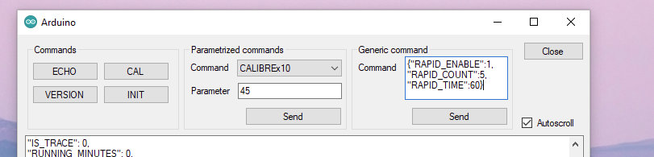

**Automatic and Manual Start**

The timed events have two methods for starting a cycle:

* Manual
* Automatic

The event can be started (manually) at any time by sending a {“TABATA_ENABLE”:1} or {“RAPID_ENABLE”:1} from the PC. On receipt of this command, the event will start immediately.

Automatic mode is enabled by {“TABATA_AUTO”:1} or {“RAPID_AUTO”:1}. In Automatic mode, the user sets up the time intervals and the software waits until the first shot has been received. Immediately following this shot, the event is enabled and proceeds normally.

**Tabata Cycles**

Tabata is used to train the user to follow the process within a defined period of time. The FreeTarget implementation uses the LED illumination to signal when to take the shot.

A Tabata cycle is defined by

LED OFF LED BLINK LED OFF LED ON

Start ---- TABATA_REST ----------------------------- TABATA_WARN_ON --- TABATA_WARN_OFF ---- TABATA_ON ---

The Tabata cycles are controlled by the following JSON commands

{"TABATA_AUTO": (0/1)} Automatically start Tabata Cycle on first shot

{"TABATA_ENABLE": (0/1)} Turn on the Tabata cycles

{"TABATA_ON”: S} On time in seconds

{"TABATA_REST": S} Rest time in seconds

{"TABATA_WARN_ON”: S} Warning time in seconds

{"TABATA_WARN_OFF": S} Warning time off in seconds

Tabata will continue until the next power cycle

Manual Example

{"TABATA_WARN_ON": 2, "TABATA_WARN_OFF":2, "TABATA_ON":7, "TABATA_REST":45, "TABATA_ENABLE":1}

Automatic Example

{"TABATA_WARN_ON": 2, "TABATA_WARN_OFF":2, "TABATA_ON":7, "TABATA_REST":45, "TABATA_AUTO":1}

**Rapid Fire Events**

Rapid fire is supported from the PC Client Program.

* From the settings menu, create a rapid fire event

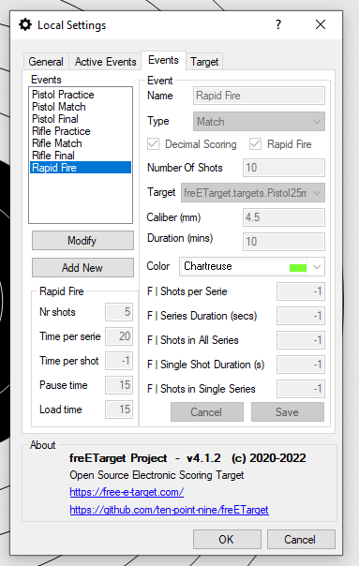

* Connect to the target
* Make sure that the rapid fire target is selected
* Start the Series
  + You will be commanded to load
  + The lights go off for the attention period
  + The lights go on for the shot duration
  + The lights go off and the shooter is commanded to unload

JSON commands

Rapid fire turns on the LED for a period of time and counts the number of shots while the LED is on.

Rapid fire cycles are controlled by the following JSON commands

{"RAPID_AUTO”: (0/1)} Enable Auto Start mode

{"RAPID_COUNT”: X} How many shots to expect

{"RAPID_ENABLE"(0/1)} Begin the rapid-fire cycle

{"RAPID_TIME": S} Rapid fire duration in seconds

{"RAPID_WAIT”: S} Wait before enabling. 1xx => Random between 0 and xx seconds

Rapid fire is executed ONCE following the receipt of the enable signal

Manual Example

{"RAPID_COUNT":5, "RAPID_TIME":60, "RAPID_WAIT”: 10, "RAPID_ENABLE":1}

Automatic Example

{"RAPID_COUNT":5, "RAPID_TIME":60, "RAPID_AUTO":1}